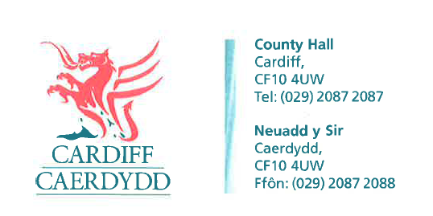
FOI Response Document
FOI10532
Thank you for your request under the Freedom of Information Act 2000 about Sructure Charts received on 22nd August 2017:
Request the organisational structure charts for Cardiff City & County Council under the Freedom of Information Act. I would like to place particular emphasis on the structures of; Estates and Facilities, Hotel Services, Capital Projects, Mechanical Engineering, Electrical Engineering, Procurement, Contracts and Supply Chain departments and Executive Team.
We have considered your request and enclose the following information:
Cardiff Councils is not responsible for hotel services however we can suppy the Organisational charts for the following services.
Please see FOI 10532 attachment
1 of 6 – Senior Mangement Structure – Executive Team
2 of 6 – Projects Design and Development Structure chart
3 of 6 – Central Trasportation services
4 of 6 - Facilities Management
5 of 6 – Strategic Estates
6 of 6 – Procurement
If you have any queries or concerns, please do not hesitate to contact us.
Please remember to quote the reference number above in any future communications.

